Name:______________________________________ Date: ____________ Period: ____
Lesson 2.2.1 Homework Problems 2-36 to 2-41 BRING YOUR BOOK HOME!
2-36. Read the Math Notes box in this lesson. Then use generic rectangles to complete the following multiplication problems.
a) 54 ·32 b) 91 ·78

2-37. Below are some new distances with given lengths to help Cecil cross the tightrope. Find at least two ways to get Cecil across. Write your solutions as numerical expressions.
a) Span of tightrope: 6 feet Given lengths: 1, 3, 4 feet
Method 1: _____________________________________

Method 2: _____________________________________
b) Span of tightrope: 8 feet Given lengths: 2, 5, 7 feet
Method 1: _____________________________________

Method 2: _____________________________________

2-38. Simplify each of the following expressions to find the length of the tightrope.
A. 5 + 2 + 8 | B. 4 + 9 + 3
C. 7 + 3 + 2 + (−4) | D. 8 + 6 + 2 + (−5)
2-39. Label the missing numbers on each of the number lines.
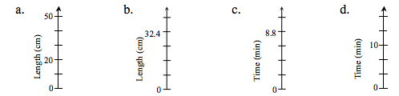
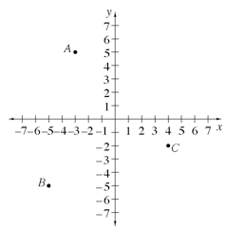
2-40. One of the topics you will review in this course is reading graphs. Look at the graph at right. This graph shows positive and negative values on both axes. It divides the flat surface into four parts, or quadrants, and is therefore called a four-quadrant graph.
a) The coordinates (the x- and y-values) for point A are (−3, 5). Explain how these numbers tell you the position of point A using the graph.

b) Name the coordinates (x, y) for points B and C.

c) If Samantha moved point A 9 units down and 6 units to the right, at what point would she end up?
2-41. Gracie loves to talk on the phone, but her parents try to limit the amount of time she talks. They decided to keep a record of the number of minutes that she spends on the phone each day. Here are the data for the past nine days: 120, 60, 0, 30, 15, 0, 0, 10, and 20.
a) Find the mean and median for the information.

b) Which of the two measures in part (a) would give Gracie’s parents the most accurate information about her phone use? Why do you think so?

